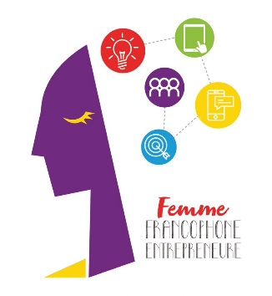

**Press Release**

# “Femme Francophone Entrepreneure” 2023:

# 27,000 Euros granted to three francophone women entrepreneurs from Lebanon and the region

***Beirut, May 24, 2023* – For the twelfth year in a row, AUF Middle East, Berytech and L’Orient-Le Jour are giving francophone women entrepreneurs the opportunity to develop their business. A Lebanese start-up, a Lebanese SME and, for the first time, an SME from the Middle East but not from Lebanon, will share a 27,000-Euro funding and will have access to training and coaching sessions for six months in Berytech.**

12 years later, the 2023 edition of the FFE will be marked by the internationalization of the competition. The call for applications is now open to the 17 AUF member countries in the Middle East other than Lebanon (Saudi Arabia, Cyprus, Djibouti, Egypt, the United Arab Emirates, Ethiopia, Iraq, Iran, Jordan, Palestine, Pakistan, Qatar, Somalia, Sudan, Syria, Turkey and Yemen).

AUF is giving francophone women entrepreneurs (SMEs/ start-ups) residing in Lebanon and to SMEs headed by francophone women residing in the abovementioned countries the chance to apply for the competition in order to receive support and funding for their projects:

* 10,000 Euros for the Lebanese SME
* 7,000 Euros for the Lebanese start-up
* 10,000 Euros for the SME from the Middle East, but not from Lebanon

The file should be submitted in French and the projects will also be presented in French in front of the jury.

**To apply:** [**https://berytech.jotform.com/231352696112048**](https://berytech.jotform.com/231352696112048)

**Deadline:** June 15, 2023

It is worth recalling that during the 2022 edition, out of the hundred files received following the call for applications, 33 were preselected prior to selecting 6 finalist candidates: 4 in the start-up category and 2 in the SME category. Rafa Hojeij (Potion Kitchen, SME), Nora Berbery (TWiLY, start-up) and Israa Hoss (Vini Fera, start-up) won the final which was held at AUF Francophone Employability Center in Beirut.

The founder of Potion Kitchen, a brand of natural beauty products made in Lebanon with ingredients extracted from Mediterranean plants without adding toxic chemicals, won the amount of 10,000 Euros, as well as a 6-month incubation and training period in Berytech. The founders of TWiLY and Vini Fera start-ups – the first one specializes in the gamification of teaching and vocational training, while the second specializes in the transformation of grape marc into quality ingredients for the cosmetics industry – won 5,000 Euros each, in addition to the same accompaniment in Berytech.

**Press contact person**  Joëlle Riachi – [joelle.riachi@auf.org](mailto:joelle.riachi@auf.org) +961 3 780 928