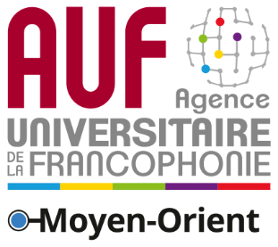
Press Release

1st International Francophone University Conference in Teheran

The Agence Universitaire de la Francophonie, the French embassy in Iran and the Ministry of Science, Research and Technology have been working for years in order to establish ambitious avenues of collaboration between the international network of francophone universities and Iranian universities. These efforts culminated in the joint organization of the first « International Francophone University Conference » to be held on June 24 and 25, 2019 at the University of Tehran.
The meeting will gather a number of Iranian and French-speaking scientists who will tackle the topic of “interdisciplinary research” and will enable fruitful exchanges aimed at strengthening cooperation among Iranian universities as well as the Francophonie in universities.
The conference will allow researchers from French-speaking countries to engage in debates through six sets of themes where interdisciplinary research will be of paramount importance:
- The issues of water, water quality preservation and water management modes, which intersect with almost all of the broad academic disciplines, such as microbiology, health, chemistry, sociology, geography, demography, town planning, law, etc.;
- Mathematics and their application in several fields of exact or human and social sciences;
- Renewable energies and natural resources management which require the scientific and academic communities to mobilize in all fields in order to come up with a sustainable response to climate issues;
- International relations and their impact on societies development or how the international dimension is at the core of quality by allowing the transversal evolution of knowledge, know-how and life skills;
- Digital humanities which stem from the symbiosis between new technologies and their uses in the field of human and social sciences;
- Lastly, the issue of university governance in the wake of the interdisciplinarity challenge or how to bring institutional strategies into line with this new requirement.

The Agence Universitaire de la Francophonie at a Glance
A worldwide association of francophone higher education and research institutions, AUF encompasses 944 academic institutions in 115 countries on all continents.
AUF regional management in the Middle East represents the Agence universitaire de la Francophonie in the region. Based in Beirut (Lebanon) since 1993, it leads a network of 83 members in 15 countries and boasts five representation offices in 3 countries in the region.

Media contact:
Joëlle Riachi
Communication officer
AUF Middle East
joelle.riachi@auf.org
Tel.: +961 1 420269

